# INDEX

| Chapter No. | Title | Page No. |
| --- | --- | --- |
|  | **Abstract** | 3 |
| **1** | **Introduction** | 4-9 |
| 1.1 | 1.1. Introduction to the project | 4-5 |
| 1.2 | 1.2. Motivation for the project | 5 |
| 1.3 | 1.3. Drawback of the existing system | 5-6 |
| 1.4 | 1.4. Problem Definition | 6-7 |
| 1.5 | .5 Relevance of the Project | 7-8 |
| 1.6 | 1.6 Methodology used | 8-9 |
| 2. | Literature Survey  2.1. Research Papers  a. Abstract of the research paper  b. Inference drawn from the paper | 10-21 |
| 3. | Requirement Of Proposed System  3.1 Functional Requirements  3.2. Non-Functional Requirements  3.3. Constraints  3.4. Hardware & Software Requirements  3.5. Techniques utilized till date for the proposed system  3.6. Tools utilized till date for the proposed system  3.7. Project Proposal | 22-25 |
| 4. | Proposed Design  4.1 Block diagram representation of the proposed system  Explanation for the block diagram  4.2. Modular diagram representation of the proposed system  Explanation for the modular block diagram  4.3 Design of the proposed system with proper explanation of each :  a. Data Flow Diagrams  b. Flowchart for the proposed system  c. State Transition Diagram/ Activity Diagram  d. Screen shot of implementation  4.4 Algorithms utilized in the existing systems  4.5. Project Scheduling & Tracking using Timeline / Gnatt Chart | 26-36 |
| 5. | Proposed Results and Discussions  5.1.Determination of efficiency  5.2.Determination of accuracy  5.3.Reports on sensitivity analysis  5.4.Graphs of : Accuracy Vs time | 37-42 |
| 6. | Plan Of Action For the Next Semester  6.1.Work done till date  6.2.Plan of action for project II | 42 |
| 7. | Conclusion | 42-43 |
| 8. | References  (In IEEE format) | 43-44 |
| 9. | Appendix  a..List Of Figures  b. Draft of the paper / Paper Published  c. Xerox of project review sheet (1 per student ) | 45-48 |

# Abstract

Waste, particularly plastic waste, poses a major challenge to environmental sustainability, overwhelming current management systems. The integration of advanced object detection technology offers a solution by accurately detecting and quantifying plastic waste from community-reported videos or photos of dumpsters. This data-driven approach enables NGOs to optimize resource allocation for waste collection and segregation, significantly improving efficiency and reducing operational bottlenecks. Additionally, the system promotes environmental engagement through features such as event announcements, educational content, and sustainability news, encouraging active community participation. Key findings highlight improvements in NGO operations, reduced waste collection times, and increased community involvement in sustainability efforts. The implications of this technology extend to scalable solutions for both urban and rural waste management, offering an innovative approach to addressing plastic waste challenges. By merging machine learning with community action, this solution bridges the gap between technology and environmental stewardship, empowering both NGOs and communities to work collaboratively towards effective waste management.

# Chapter 1 : Introduction

This chapter presents an overview of the project, exploring the motivation, challenges in existing waste management systems, and the innovative solutions proposed through our platform. It highlights how cutting-edge object detection technology empowers users and NGOs to report and manage waste more efficiently by analyzing media submissions to detect and quantify plastic waste. The platform optimizes resource allocation, streamlines waste collection, and enhances community engagement through real-time updates and educational content on sustainable practices. By addressing critical gaps in recycling infrastructure and public awareness, this project aims to foster cleaner, more sustainable environments.

**1.1. Introduction to the project**

In the era of rapid technological advancements and increasing environmental concerns, our project emerges as a beacon of innovation and community empowerment in waste management. Our platform leverages cutting-edge object detection technology to enable users to report issues related to dumpsters in their vicinity by simply uploading videos or photos. This technology meticulously analyzes the media to detect and count the number of plastic items, providing an accurate assessment of waste quantities.

This feature is transformative for NGOs engaged in waste management drives. Armed with precise data, these organizations can better allocate their resources—trucks, collectors, manpower, and plastic bags—streamlining their operations and significantly reducing the time and effort required for waste segregation. This allows NGOs to focus more on the impactful work of cleaning and less on logistical challenges.

Our platform is designed to foster a collaborative community spirit. NGOs can post about upcoming drives and events, inviting the community to participate and contribute to the cause. This not only helps in mobilizing resources but also strengthens the bond between the organization and the community it serves.

Furthermore, our project is dedicated to spreading awareness and education about environmental sustainability. The platform offers a wealth of news and articles on innovative ways to reduce, reuse, and recycle, keeping users informed and engaged. By promoting best practices and new technologies in waste management, we aim to inspire individuals and communities to take proactive steps towards a cleaner, greener future.

In essence, our project is more than just a technological solution; it is a comprehensive platform that empowers NGOs, engages communities, and promotes environmental stewardship. Together, we can make a significant impact in managing waste more efficiently and creating a sustainable environment for future generations.

**1.2. Motivation for the project**

The motivation behind the EnviroScan project lies in our dedication to empowering communities and fostering environmental stewardship through innovation. Waste management, particularly the rampant issue of plastic pollution, poses significant challenges for both local communities and NGOs. With limited resources and inefficient processes, the task of tracking, segregating, and managing waste can often feel overwhelming. Through EnviroScan, we aim to leverage advanced object detection technology to simplify waste reporting and resource allocation, enabling more effective waste management. By providing a platform that not only enhances operational efficiency but also engages the community, we hope to drive collective action towards a cleaner and more sustainable future. EnviroScan embodies our belief that technology, when used responsibly, can be a powerful tool to solve real-world problems and foster collaboration. We envision a future where technology serves as a catalyst for environmental awareness, helping individuals and organizations unite in the shared goal of protecting our planet for future generations.

**1.3. Drawback of the existing system**

While the existing systems may have made significant strides in improving accessibility for domestic waste management, there are still areas where they may have limitations or room for improvement:

* Inadequate Recycling Facilities: Many regions lack sufficient recycling infrastructure, leading to recyclable materials being disposed of improperly. Even where facilities exist, they are often underfunded and inefficient, discouraging public participation in recycling.
* Inefficient Collection Schedules: Waste collection schedules frequently fail to match actual community needs, resulting in overflowing dumpsters, delays, and missed pickups, contributing to environmental and hygiene issues.
* Limited Public Awareness: A lack of widespread education on sustainable waste management practices leads to improper disposal and low recycling participation.
* Poor Data Integration: Current systems often lack real-time data and analytics integration, hindering efficient decision-making and operational effectiveness.
* Slow Response to Complaints: Existing complaint management systems are typically slow, leading to unresolved waste-related issues and dissatisfaction among residents.

**1.4. Problem Definition**

In an era defined by rapid urbanization and mounting environmental concerns, efficient waste management has emerged as a crucial challenge for both urban and rural communities alike. Despite ongoing efforts by governments, NGOs, and community organizations, many areas continue to struggle with managing waste effectively. This inefficiency manifests in various ways, including improper disposal of recyclable materials, delayed and inconsistent waste collection schedules, and a pervasive lack of public awareness regarding environmentally sustainable waste management practices. These shortcomings not only degrade the cleanliness and hygiene of communities but also contribute to the growing global waste crisis, particularly the overwhelming accumulation of plastics.

This project seeks to tackle these issues head-on by integrating cutting-edge technology with a strong focus on community engagement and education. At the heart of the initiative is the use of advanced waste detection and monitoring systems that utilize object detection technology to accurately identify, quantify, and categorize waste from user-submitted photos and videos. This enables a more efficient assessment of the amount and type of waste being generated, providing real-time data that can be used to optimize collection routes and schedules. By aligning waste collection with actual needs, our solution reduces delays, prevents overflowing dumpsters, and ensures timely waste pickup, ultimately improving the overall cleanliness of neighborhoods.

Beyond technological innovations, the project also emphasizes the importance of community participation and environmental education. Public awareness campaigns are designed to educate individuals on the benefits of recycling and proper waste disposal, encouraging active participation in sustainable practices. In addition, our platform integrates a robust complaint management system that allows residents to report issues related to waste disposal and recycling in real-time. By providing an efficient response mechanism, we ensure that complaints are addressed quickly, fostering a sense of accountability and transparency within the waste management process.

Ultimately, this initiative goes beyond just waste collection—it creates a holistic ecosystem that empowers communities to take ownership of their environment. By combining technology, community involvement, and education, we aim to foster cleaner, greener, and more sustainable living environments for all, paving the way for a future where waste management is not only efficient but also a shared responsibility among individuals and organizations.

**1.5 Relevance of the Project**

The relevance of this project is rooted in the pressing global need for sustainable and efficient waste management systems, especially in the face of growing urbanization and escalating environmental challenges. With increasing amounts of waste, particularly plastics, being improperly disposed of, the impact on ecosystems, public health, and urban hygiene is becoming more severe. This project directly addresses these concerns by introducing a technology-driven solution that optimizes waste collection and recycling processes, thereby reducing environmental pollution and promoting a cleaner living environment.

Moreover, the project is highly relevant to community-driven environmental initiatives. By integrating real-time waste monitoring and detection systems, it enhances operational efficiency for waste management organizations, particularly NGOs. The project’s focus on public awareness and education also ensures that individuals are equipped with the knowledge to actively participate in sustainable waste practices, making this initiative a critical tool in fostering environmental stewardship.

In the broader context, this project contributes to global sustainability goals, aligning with efforts to reduce plastic waste, minimize landfill usage, and promote recycling and responsible waste disposal. By empowering communities and organizations to collaborate through a shared platform, the project is poised to have a lasting impact on how waste is managed at both local and regional levels.

**1.6 Methodology used**

The methodology adopted for this project integrates advanced technology, data-driven analysis, and community involvement to create a comprehensive waste management solution. The following key steps outline the methodology used:

1. Object Detection Technology:

The project utilizes state-of-the-art object detection algorithms, such as YOLO (You Only Look Once), to analyze images submitted by users. This technology accurately detects and counts plastic waste items, providing real-time data on the type and quantity of waste. This data is then used to optimize resource allocation and waste collection schedules.

2. Data Collection and Integration:

User-generated content in the form of photos is collected via the platform. The collected data is processed and integrated into a centralized database that provides actionable insights. This allows NGOs and waste management authorities to track waste accumulation, identify high-waste areas, and allocate resources more effectively.

3. Public Awareness and Education Campaigns:

The platform includes educational resources that promote sustainable waste management practices. Campaigns are designed to inform users about the importance of recycling, waste segregation, and responsible disposal methods. By engaging users through interactive content, the platform aims to increase community participation and environmental awareness.

4. Community Reporting and Complaint Management:

A built-in complaint management system allows residents to report waste-related issues, such as missed pickups or overflowing dumpsters, in real time. This ensures quick response and resolution of complaints, fostering accountability and improving overall service delivery.

5. Collaboration with NGOs:

The platform facilitates collaboration between communities and NGOs by enabling NGOs to post about upcoming waste collection drives and events. The platform’s analytics provide NGOs with accurate data to plan and allocate resources for their activities, ensuring that they can address waste management challenges more effectively.

6. Feedback and Continuous Improvement:

Data from the platform is continually analyzed to refine and improve the waste management processes. User feedback and system performance data are used to enhance detection algorithms, optimize scheduling, and improve the overall effectiveness of the platform.

# Chapter 2: Literature Survey (with citation of references)

This chapter provides a comprehensive review of ten research papers that focus on object detection in waste management using deep learning techniques. Each paper's abstract is discussed, followed by the inference drawn from its findings. These papers highlight various approaches, such as Faster RCNN, YOLO, and EfficientNet, for waste detection and classification, showcasing advancements in accuracy and efficiency. The insights gathered from these studies inform our approach to integrating object detection models into waste management applications, further contributing to the development of sustainable and automated waste solutions.

**2.1. Research Papers**

1. **E-Safe: An E-waste Management and Awareness Application using YOLO Object Detection**
2. **Abstract :** Technology and related fields are advancing rapidly in today’s era, which is leading to the increased usage of electronic equipment especially mobile phones. This rapid growth in the usage of technological equipment gives rise to E-waste generation since the advancement in technology forces the users to replace their existing equipment with the advanced ones. This throw on the scrapheap is increasing exponentially, leading to the immense generation of E-waste. The growing amount of waste must be properly handled and disposed off. E-waste mainly consists of chemicals and metals, which can be harmful or toxic in nature. Giving a blind eye to the handling of this waste can lead to great mishaps. Here, it mainly focuses on the technologies used for the handling of E-waste and provide a technical solution, which is an Android Application. This will take the image for processing and based on YOLO algorithms, it will identify the electronic device from image and will list out the components of identified device. The final output of the application will make the E-waste management process easier for managing data and will work as an awareness tool to make people aware about the E-Waste threats.
3. **Inference drawn from the paper : Prof. Khalid Alfatmi, Ms. Falguni Shashikant Shinde et al. (2023)** The paper highlights the urgent issue of electronic waste (e-waste) generation due to the rapid advancement and increased usage of electronic devices, particularly mobile phones, which compels users to frequently upgrade to newer models. This surge in e-waste, containing harmful chemicals and metals, poses significant environmental and health risks if not properly managed. To address these challenges, the paper proposes an innovative Android application that employs YOLO (You Only Look Once) algorithms to process images of electronic devices, identify them, and list their components. This application aims to simplify e-waste management by organizing data while simultaneously serving as an awareness tool to educate the public about the dangers associated with e-waste. Ultimately, the paper advocates for leveraging technology to enhance e-waste handling practices and promote responsible disposal methods.

**2) Implementation of Faster Region-Based Convolutional Neural Network for Waste Type Classification**

1. **Abstract :** The improper disposal of garbage is one of the factors that contribute to the problems that are visible in the environment, and these problems have a significant influence. The digestive issue is one of the problems caused by the increase in the population of insects and the variety of different types of pests. If waste is not recycled and managed effectively, it can negatively impact economic growth and contribute to air pollution and other health issues. Integrating computer technology, such as object recognition, might be helpful in waste management. At this point, the most popular approach to object detection is called deep learning. Therefore, this paper presents a waste recognition using Faster Region-Based Convolutional Neural Network. The research focused on recognizing plastic and disposable diapers as two separate classes since disposable diapers and plastics are essential in modern society. Convolutional neural network (CNN) which comes under deep learning has been widely used in object recognition or classification due to its effectiveness. In the Faster RCNN, we used two separate networks to predict the region proposal reshaped by a Region of Interest (RoI) pooling layer to classify the images. From the result, it can be observed that our proposed system has achieved an average accuracy of 91.2%.
2. **Inference drawn from the paper : Jamilin Rashida, Raseeda Hamzah and et al. (2022)** The paper addresses the critical environmental issues stemming from improper waste disposal, which exacerbates insect populations and various pests, contributing to health and economic challenges. Ineffective waste management, particularly in recycling, can lead to air pollution and other significant health risks. To tackle these issues, the research introduces a waste recognition system utilizing a Faster Region-Based Convolutional Neural Network (Faster R-CNN), focusing specifically on identifying plastic waste and disposable diapers as two distinct categories. The study employs convolutional neural networks (CNNs), a prominent deep learning technique known for its efficacy in object recognition. The proposed system utilizes two separate networks to generate region proposals, which are then classified using a Region of Interest (RoI) pooling layer. The results demonstrate that the system achieved an impressive average accuracy of 91.2%, showcasing its potential as an effective tool in waste management and recycling efforts.\

**3) SSD based waste separation in smart garbage using augmented clustering NMS**

1. **Abstract :** Object detection plays a pivotal role in autonomous systems helps to build the machines to be intelligent as humans that leads to build an Artificial Intelligence application used for society,Industries,face-recognition and so-on. Nowadays, it is difficult to manage the waste generated by humans and industries which is increasing rapidly day by day needs to address the problem to make automation for separating the Bio-degradable and Non-Bio degradable waste. Although humans are tried to manage impact of waste management in society to maintain the eco-system by implementing a separate trash for Bio and Non-bio waste. Sometimes it is difficult to follow for the separation of waste manually by humans. There is no existing sensor to identify the types of wastes. In this proposed system, it evolves the implementation of the bio-degradable and non-bio degradable object detection method to help to detect these objects automatically with the augmented clustering NMS using Single-shot detector methods. The enhanced augmented clustering algorithm effectively detects the multiple objects in the video along with the respective bio or non-bio classification custom object detection model. With the build thousand images for each class custom dataset model to train the objects using deep learning neural network. A custom object detection data model is built with the help of NVIDIA GPU RTX 4 GB using tensorflow model. Here the results are interpreted with the mean average precision value of 0.965 with ACNMS Single shot object detector which is effectively detected with the new enhanced technique.
2. **Inference drawn from the paper : M. Karthikeyan, T. S. Subashini and et al. (2021)** The paper highlights the crucial role of object detection in autonomous systems, enabling machines to achieve human-like intelligence and enhancing various applications, including those in society and industry, such as waste management. As the volume of waste generated by humans and industries continues to escalate, effective solutions for separating biodegradable and non-biodegradable waste are urgently needed. While efforts have been made to manage waste through designated trash bins, manual separation poses significant challenges. The proposed system addresses this gap by implementing an automatic detection method for biodegradable and non-biodegradable waste using an augmented clustering Non-Maximum Suppression (NMS) approach with Single Shot Detector (SSD) techniques. This enhanced augmented clustering algorithm efficiently detects multiple objects in video streams, categorizing them accurately as biodegradable or non-biodegradable. The system utilizes a custom dataset model, trained on thousands of images per class using deep learning neural networks and powered by an NVIDIA GPU RTX with 4 GB memory. The results demonstrate a mean average precision of 0.965 with the ACNMS SSD, showcasing the effectiveness of this innovative technique in waste classification.

**4) ScrapNet: An Efficient Approach to Trash Classification**

1. **Abstract :** As people have become more aware of their actions and how they affect their surroundings, they have realized the dire state of the environment. As a result, the recycling movement has gained momentum as a measure to save it. Contemporarily, the recycling industry has not seen a major shift and the problems that existed decades earlier persist. Trash classification is at the core of these problems, because if you can’t classify it, obviously you can’t recycle it. Manual classification often leads to misclassification as humans classify or judge things based on their experiences, knowledge, and not just absolute facts. Additionally, if the waste to be sorted is toxic, being in direct contact may be physically harmful to the people involved. Until a solution is found for this problem, the recycling industry won’t be on par with the rise in recycling culture. Thus, this is the problem we have set out to solve; this paper proposes a Deep Learning model based on EfficientNet Architecture that can classify different kinds of trash with an accuracy high enough to make it a viable solution for the industry while using a comparatively lower number of parameters than existing methods. We achieved an accuracy of 98% on the TrashNet dataset, the standard data for Trash classification, and outperformed all existing models. Additionally, as no large dataset with a varied set of trash images was present, we created a new dataset of 8135 images by combining various datasets and standardized them, achieving a classification accuracy of 92.87% with EfficientNet B3.
2. **Inference of the paper : Abhishek Masand , Suryansh Chauhan and et al. (2021)** The paper addresses the pressing issues of trash classification within the recycling industry, highlighting how the lack of effective classification techniques hampers recycling efforts despite the growing awareness of environmental issues. Manual classification methods often lead to misclassification due to subjective human judgment, which can be particularly dangerous when dealing with toxic waste. To tackle this problem, the study proposes a Deep Learning model utilizing EfficientNet Architecture, aimed at improving trash classification accuracy. The model achieves an impressive accuracy of 98% on the TrashNet dataset, surpassing existing models and demonstrating its potential as a practical solution for the recycling industry. Furthermore, recognizing the absence of a comprehensive dataset with diverse trash images, the authors developed a new dataset comprising 8,135 images from various sources, resulting in a classification accuracy of 92.87% with EfficientNet B3. This work not only advances trash classification technology but also supports the broader goal of enhancing recycling practices and promoting environmental sustainability.

**5) YOLO-Green: A Real-Time Classification and Object Detection Model Optimized for Waste Management**

1. **Abstract :** Deep neural networks (DNNs) play an important role in our daily lives, from aiding us in menial tasks to solving world issues such as cancer cell detection. However, few pieces of research have been conducted using DNNs and deep learning models as a medium to help classify and detect trash, in efforts to solve our global waste crisis. This is because current DNNs struggle to be both efficient and accurate while detecting indistinct objects such as waste. To address this issue, this work focuses on YOLO-Green, a novel real-time object detection model designed specifically for trash detection. The model is trained on a dataset gathered from real-world trash divided into seven of the most common types of solid waste. With only 100 epochs of training, YOLO-Green achieves an outstanding mAP of 78.04%, FPS of 2.72, while retaining a model size of only 117 MB. Based on the original object detection of YOLOv4, YOLO-Green exceeds YOLOv4 and other popular deep learning models in both its accuracy and efficiency, while maintaining a relatively small model size. Ultimately, this study sheds a positive light on the potential of using deep learning models as an alternative to manual waste management.
2. **Inference of the paper : Wesley Lin (2021)** This study highlights the potential of Deep Neural Networks (DNNs) in addressing global waste management issues, specifically through the development of YOLO-Green, a novel real-time object detection model tailored for trash classification. While DNNs have proven effective in various fields, their application in waste detection has been limited due to challenges in accurately identifying indistinct objects. YOLO-Green aims to overcome these challenges by training on a dataset comprising seven common types of solid waste, achieving an impressive mean Average Precision (mAP) of 78.04% with just 100 training epochs. The model operates at a frame rate of 2.72 FPS and maintains a compact size of only 117 MB, outperforming both YOLOv4 and other established deep learning models in terms of accuracy and efficiency. This research underscores the viability of employing advanced deep learning techniques as alternatives to traditional manual waste management practices, contributing positively to efforts in tackling the global waste crisis.

**6) Smart Waste Management: Waste Segregation using Machine Learning**

1. **Abstract :** In the digitized era, the role of smart mechanisms plays a vital role and one among them is the segregation of waste. To make use of proper disposal and waste management techniques, the segregation of wastes is essential. In the existing systems, drones are used for identifying waste using image processing, and deep learning and use GPS, and GSM methods to identify and send locations to the authorities. The enhancement achieved is to analyze and implement waste segregation with the help of image classification and multi-object detection. Waste management may therefore be done more efficiently with an accuracy of 95% with a mean average of 87.4% which in turn helps significantly to reduce labor costs.
2. **Inference of the paper : Gayathri Rajakumaran, Shola Usharani and et al. (2023)** This paper addresses the critical need for effective waste segregation in the context of modern waste management by exploring the integration of smart mechanisms. It highlights the use of drones equipped with image processing and deep learning technologies, coupled with GPS and GSM for location tracking, to identify waste. The research enhances existing systems by focusing on advanced image classification and multi-object detection techniques for waste segregation. The proposed approach achieves an impressive accuracy of 95% and a mean average precision of 87.4%, leading to more efficient waste management while significantly reducing labor costs. Ultimately, this study demonstrates the potential of technological integration in promoting sustainable waste disposal practices and addressing environmental challenges.

**7) Recyclable solid waste detection based on image fusion and convolutional neural network**

1. **Abstract :** The most solid waste image datasets usually contain only a single object with a plain background, which is quite different from the real environment. In addition, the waste images labeling process takes a long time and is labor cost. To address these problems, we proposed an effective method to extend the dataset based on image fusion. Herein, we use image fusion technology to make a recyclable solid waste dataset Trash-Fusion automatically, where the images contain different categories of objects with complex background, and all classification and location labels are collected in the process of image fusion. Moreover, an actual scene dataset Trash-Collect is constructed, images of which are downloaded from the Internet or collected by ourselves. A mixed dataset of Trash-Fusion and Trash-Collect is sent to several convolutional neural networks for training, and YOLO v5 achieves the highest detection precision with 60 FPS.
2. **Inference from the paper : Yao Xiao, Bin Chen and et al. (2024)** This paper proposes an innovative solution to the limitations of existing solid waste image datasets, which typically feature single objects against plain backgrounds, diverging from real-world scenarios. To tackle the challenges of labor-intensive image labeling and dataset diversity, we introduce a method utilizing image fusion technology to create an enhanced dataset called Trash-Fusion. This dataset comprises images featuring multiple categories of objects set against complex backgrounds, with all classification and location labels automatically generated during the fusion process. Additionally, we construct a real-world dataset named Trash-Collect, sourcing images from the internet and personal collections. By combining the Trash-Fusion and Trash-Collect datasets, we train several convolutional neural networks, with YOLO v5 achieving the highest detection precision at 60 FPS, thus demonstrating the effectiveness of our approach in improving waste detection in complex environments.

**8) Solid Waste Detection in Cities Using Remote Sensing Imagery Based on a Location-Guided Key Point Network With Multiple Enhancements**

1. **Abstract :** Solid waste is a widespread problem that is having a negative effect on the global environment. Owing to the ability of macroscopic observation, it is reasonable to believe that remote sensing could be an effective way to realize the detection and monitoring of solid waste. Solid waste is usually a mixture of various materials, with a randomly scattered distribution, which brings great difficulty to precise detection. In this article, we propose a deep learning network for solid waste detection in urban areas, aiming to realize the fast and automatic extraction of solid waste from the complicated and large-scale urban background. A novel dataset for solid waste detection was constructed by collecting 3192 images from Google Earth (with a resolution from 0.13 to 0.52 m), and then a location-guided key point network with multiple enhancements (LKN-ME) is proposed to perform the urban solid waste detection task. The LKN-ME method uses corner pooling and central convolution to capture the key points of an object. The location guidance is realized through constraining the key point locations situated of the annotated bounding box of an object. Multiple enhancements, including data mosaicing, an attention enhancement, and path aggregation, are integrated to improve the detection accuracy. The results show that the LKN-ME method can achieve a state-of-the-art AR 100 (the average recall computed over 100 detections per image) of 71.8% and an average precision of 44.0% for the DSWD dataset, outperforming the classic object detection methods in solving the solid waste detection problem.
2. **Inference from the paper : Huifang Li , Chao Hu and et al. (2023)** This paper presents a deep learning network designed for the detection and monitoring of solid waste in urban environments, addressing the widespread environmental issues caused by solid waste accumulation. Recognizing the challenges posed by the complex and varied nature of solid waste, we developed a novel dataset comprising 3,192 high-resolution images sourced from Google Earth, with resolutions ranging from 0.13 to 0.52 m. We introduce the location-guided key point network with multiple enhancements (LKN-ME) to facilitate the automatic extraction of solid waste from intricate urban backgrounds. The LKN-ME network employs corner pooling and central convolution techniques to identify key points of objects, with location guidance provided by constraining these points to the annotated bounding boxes. To further enhance detection accuracy, we integrate several improvements, including data mosaicing, attention enhancement, and path aggregation. The LKN-ME method achieves a state-of-the-art average recall of 71.8% and an average precision of 44.0% on the DSWD dataset, surpassing traditional object detection approaches and demonstrating its effectiveness in tackling the solid waste detection problem in urban settings.

**9) A Survey on Waste Detection and Classification Using Deep Learning**

1. **Abstract :** Waste or trash management is receiving increased attention for intelligent and sustainable development, particularly in developed and developing countries. The waste or trash management system comprises several related processes that carry out various complex functions. Recently, interest in deep learning (DL) has increased in providing alternative computational techniques for determining the solution to various waste or trash management problems. Researchers have concentrated on this domain, and as a result, significant research has been published, particularly in recent years. According to the literature, a few comprehensive surveys have been done on waste detection and classification. However, no study has investigated the application of DL to solve waste or trash management problems in various domains and highlight the available datasets for waste detection and classification in different domains. To this end, this survey contributes by reviewing various image classification and object detection models, and their applications in waste detection and classification problems, providing an analysis of waste detection and classification techniques with precise and organized representation and compiling over twenty benchmarked trash datasets. Also, we backed up the study with the challenges of existing methods and the future potential in this field. This will give researchers in this area a solid background and knowledge of the state-of-the-art deep learning models and insight into the research areas that can still be explored.
2. **Inference from the paper : Haruna Abdu, Mohd Halim Mohd Noor and et al. (2022)** This paper presents a comprehensive survey of waste management, focusing on the application of deep learning (DL) techniques to address various challenges in waste detection and classification across multiple domains. As both developed and developing countries increasingly prioritize intelligent and sustainable waste management systems, this study highlights the complexity of these processes and the growing interest in utilizing DL for effective solutions. Despite the existing literature on waste detection and classification, there has been a lack of studies specifically examining the application of DL in this field and compiling available datasets. To bridge this gap, our survey reviews various image classification and object detection models relevant to waste management, offering an organized analysis of techniques and compiling over twenty benchmarked trash datasets. Additionally, the paper discusses the challenges faced by current methods and explores future research potentials, providing researchers with a solid foundation in state-of-the-art DL models and identifying areas for further investigation in waste management.

**10) Real-Time Garbage Object Detection With Data Augmentation and Feature Fusion Using SUAV Low-Altitude Remote Sensing Images**

1. **Abstract :** Recently, a number of nature reserves have been shut down because of serious pollution from tourist garbage. Garbage monitoring in high-altitude natural reserves using small unmanned aerial vehicle (SUAV) remote sensing is an important and urgent need for environmental protection. In order to help cleaners to eliminate garbage more conveniently and quickly, a novel approach is proposed to detect scattered garbage regions in real time using low-altitude remote sensing videos captured by SUAVs. First, the high-resolution, low-altitude, multitemporal remote sensing images and videos containing scattered garbage were collected through SUAV and then proposed a data augmentation method to expand the training samples. Second, the Yolov4 detection network was used to classify the scattered garbage regions. Finally, the location of the object was roughly calculated according to the altitude, flight direction, global positioning system, and digital elevation model (DEM). Then, the garbage object was marked on the video, while the object location was marked on the map. Experimental results show that the proposed method achieves a mean accuracy of 91.34% and provides better performances on the real data set compared with state-of-the-art methods.
2. **Inference from the paper : Weiyang Chen , Haifeng Wang and et al. (2022)** This paper proposes a novel approach for monitoring garbage in high-altitude natural reserves using small unmanned aerial vehicles (SUAVs) equipped with low-altitude remote sensing capabilities. As pollution from tourist garbage poses a significant threat to the environment, timely detection and removal of waste are crucial. The study involves the collection of high-resolution, multitemporal remote sensing images and videos of scattered garbage through SUAVs, followed by a data augmentation method to enhance the training samples. The Yolov4 detection network is employed to classify the identified garbage regions, while the object location is estimated using altitude, flight direction, global positioning system (GPS) data, and digital elevation models (DEMs). The results indicate that this method achieves a mean accuracy of 91.34%, demonstrating superior performance on real datasets compared to existing state-of-the-art techniques, thereby facilitating more efficient garbage collection in sensitive ecological areas.

# Chapter 3: Requirements for the proposed system

The requirements for the project titled **"EnviroScan: Community and NGO Waste Solution"** comprise the functional, non-functional needs, constraints, hardware and software specifics, tools and techniques applied so far, and a final project proposal after analyzing these requirements. These points are essential in shaping the direction of development and ensuring alignment with project goals.

**3.1 Functional Requirements**

The functional requirements of the EnviroScan project include:

* **Waste Detection and Classification**: The system must detect, classify, and quantify plastic waste in photos or videos submitted by users through object detection algorithms such as YOLO.
* **Data Collection and Storage**: All user-submitted data, including media content and waste statistics, must be stored securely in a centralized database for easy access by NGOs and waste management authorities.
* **Dynamic Waste Collection Schedules**: Based on real-time data from waste detection, the system must dynamically adjust waste collection schedules to meet the actual demand in different locations.
* **User Complaint Reporting**: Users must be able to report waste-related issues such as overflowing dumpsters and missed pickups, which can then be acted upon by relevant authorities.
* **NGO Collaboration and Event Posting**: The system should allow NGOs to post about upcoming waste collection drives and community engagement events.
* **Educational Resources**: The platform should deliver educational content, such as articles and tutorials, to promote sustainable waste management practices and community awareness.

These functional requirements ensure that the platform achieves its primary objectives of efficient waste management, community involvement, and educational outreach.

**3.2. Non-Functional Requirements**

Non-functional requirements for the EnviroScan project include:

* **Scalability**: The system should be able to handle increasing numbers of users and waste detection requests without a significant drop in performance.
* **Reliability**: The system must be reliable, with minimal downtime, ensuring that the platform is available when users or NGOs need to access it.
* **Usability**: The interface should be user-friendly for both NGO representatives and community members, allowing easy submission of media and interaction with the system.
* **Performance**: The object detection and classification algorithms must operate efficiently, providing accurate results within a short time frame.
* **Security**: The system must secure sensitive user data, including locations and submissions, protecting against unauthorized access.

These non-functional requirements are critical to ensuring that the platform operates efficiently, securely, and with scalability in mind as user demand grows.

**3.3. Constraints**

The constraints under which the EnviroScan system must operate include:

* **Internet Connectivity**: The platform may face challenges in areas with limited or unreliable internet access, potentially delaying the submission of waste-related media.
* **Resource Limitations**: NGOs may have limited availability of vehicles, personnel, and collection bins, which can affect the implementation of optimized waste collection schedules.
* **Budget Limitations**: The development and maintenance of the object detection system, as well as cloud infrastructure, may face budget constraints, especially for smaller NGOs.

Recognizing these constraints early on allows the project team to design solutions that accommodate these challenges, such as offline data storage or prioritizing essential functionalities in budget-conscious environments.

**3.4. Hardware & Software Requirements**

The hardware and software required for the project are outlined as follows:

* **Hardware**:
  + High-performance GPUs to run YOLO-based object detection algorithms.
  + Smartphones or other mobile devices with camera functionality for users to capture and submit waste media.
* **Software**:
  + A robust database system (e.g., MySQL or MongoDB) for storing user submissions, waste data, and system metrics.
  + YOLOv9 object detection models for identifying plastic waste in submitted media.
  + Front-end development frameworks (React, Angular) for creating intuitive user interfaces.
  + Cloud hosting platforms such as AWS or Google Cloud for real-time data processing and storage.

These hardware and software components are essential for ensuring that the system can process large volumes of data efficiently and accurately while providing a seamless user experience.

**3.5. Techniques utilized till date for the proposed system**

Several techniques have been utilized so far in the development of the system:

* **Computer Vision**: Techniques for object detection are used to identify and classify plastic waste in media submissions.
* **Data Integration**: User-generated content is aggregated and processed, providing real-time waste analytics for NGOs and authorities.

These techniques ensure that the platform can efficiently process data, optimize waste management processes, and promote sustainability.

**3.6. Tools utilized till date for the proposed system**

The tools applied in the development of EnviroScan include:

* **YOLO (You Only Look Once)**: A powerful object detection tool for classifying and counting plastic items in images or videos.
* **React/Angular**: Front-end frameworks for building user-friendly interfaces.

These tools provide the necessary technological infrastructure to support the object detection algorithms and platform functionality.

**3.7. Algorithms utilized in the existing systems**

The algorithms that have been implemented or considered for EnviroScan include:

* **YOLOv9 Object Detection Algorithm**: This algorithm is used to detect and classify plastic waste from media submissions.
* **Dynamic Scheduling Algorithm**: Optimizes waste collection routes based on real-time waste data from users, reducing delays and overflows.
* **Data Analysis Algorithms**: Used for generating actionable insights from collected data, allowing NGOs to make informed decisions about resource allocation.

These algorithms are critical for the system’s core functionality of waste detection, optimized scheduling, and data-driven decision-making.

# Chapter 4: Proposed Design

This chapter provides a comprehensive design of the EnviroScan system, focusing on both conceptual and modular architecture. It begins with the architectural design through block diagrams, detailing the system’s core components and their interactions. The chapter further elaborates on the data flow across various levels with DFD diagrams and presents flowcharts to illustrate the logical flow of processes. Additionally, screenshots of the implementation highlight key features of the system. The chapter concludes with a Gantt chart, showcasing the project’s timeline, scheduling, and task tracking.

**4.1. Block diagram representation of the proposed system**

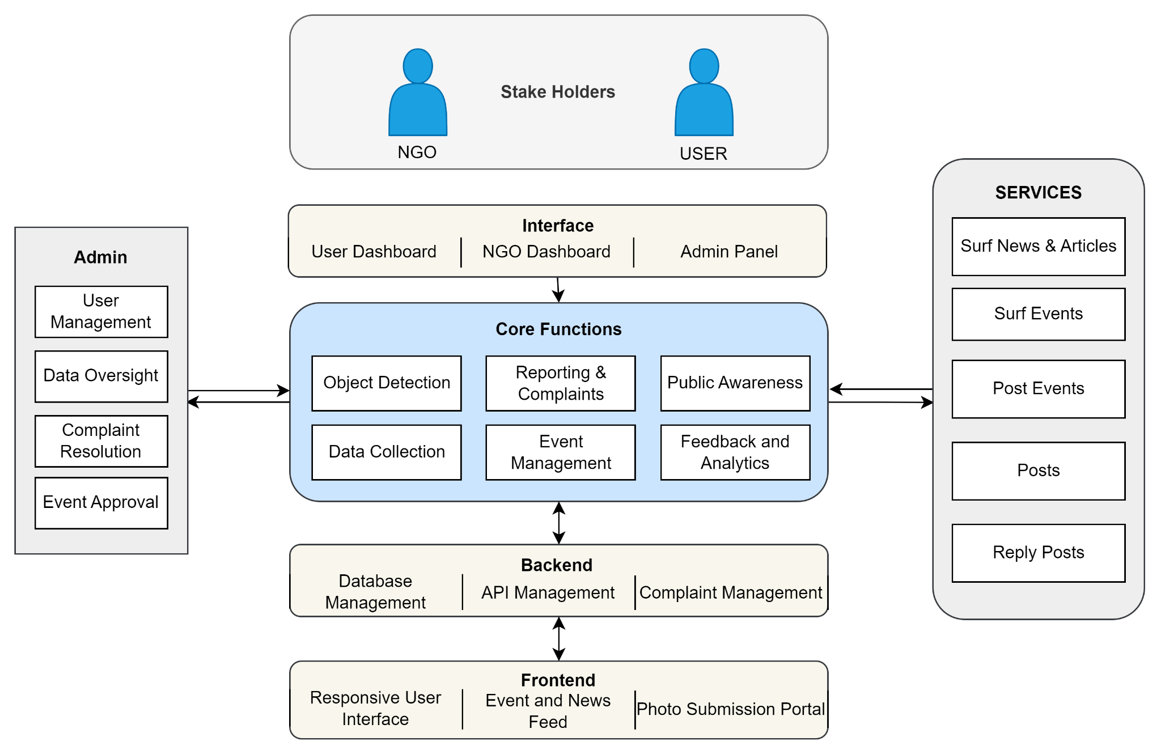

**Fig 4.1. Block diagram**

**Explanation for the block diagram**

This block diagram illustrates the architecture of the EnviroScan system. It is divided into multiple components and organized layers, creating a comprehensive waste management platform.

User Layer: This layer includes the primary stakeholders:

* General Public (USER): Individuals who utilize the platform to report issues, view educational content, and participate in events.
* NGOs: Organizations involved in waste management and awareness who can post events, access analytics, and collaborate with the community.

Interface: The interface provides different access points for various users:

* User Dashboard: A portal for users to submit photos, browse events, surf news, and interact with the community.
* NGO Dashboard: A management tool for NGOs to organize events, track waste reports, and view analytics.
* Admin Panel: The control center for managing the system, including user and content moderation.

Core Functions: This section encompasses the key functionalities that drive the platform:

* Object Detection: Using YOLO, detects and classifies waste types from submitted photos.
* Data Collection: Collects user-generated content for analysis and integration.
* Reporting & Complaints: Allows users to report waste-related issues.
* Event Management: Facilitates the creation and promotion of waste collection events by NGOs.
* Public Awareness: Educates the public about sustainable waste practices.
* Feedback and Analytics: Analyzes user data for insights and provides feedback mechanisms.

Services: These are the main features available to users and NGOs:

* Surf News & Articles: Access to educational resources about waste management.
* Surf Events: View and participate in upcoming events related to waste collection and awareness.
* Post Events: NGOs can create events for community participation.
* Posts: Users can engage with various posts related to waste and environment.
* Reply Posts: Enables interaction and discussion on posts.

Backend: The backend layer handles data management and processing:

* Database Management: Stores user data, photos, events, and reports.
* API Management: Facilitates communication between the frontend and core functionalities.
* Complaint Management: Backend processing for handling reports and complaints from users.

Frontend: The frontend layer provides the user interface:

* Responsive User Interface: A web and mobile-friendly interface for accessing the platform.
* Event and News Feed: Displays latest news, articles, and event details.
* Photo Submission Portal: Easy-to-use tool for uploading waste-related photos.

**4.2. Modular diagram representation of the proposed system**

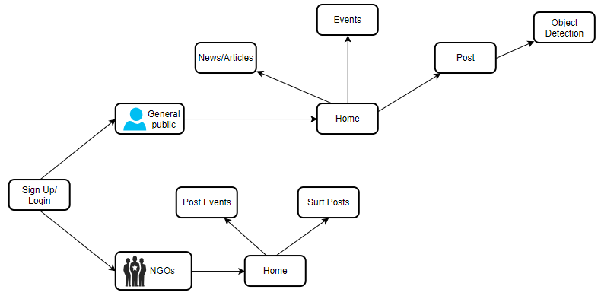

**Fig 4.2. Block diagram**

**Explanation for the modular block diagram**

This modular diagram illustrates the interaction between two main user types—general public and NGOs—and their access to system functionalities. Both user types can sign up or log in to the system. Once logged in, the general public can navigate to the home page to access news/articles, events, and the post feature, which leads to object detection. NGOs can log in and access the home page to post events and surf posts. This diagram succinctly represents the user journey and the functionalities each user type can access within the system.

**4.3 Design of the proposed system with proper explanation of each :**

**a. Data Flow Diagram ( Level 0,1,2)**

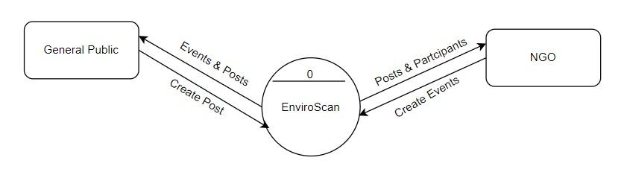

**fig 4.3.1. DFD Level 0**

The Level 0 DFD of the EnviroScan system provides a high-level overview of the interactions between the system, general public, and NGOs. The public can create posts and receive information about events and posts through the system. NGOs can create events and view posts and participant details to plan or promote activities. The EnviroScan system acts as the central platform, facilitating the exchange of posts, events, and participant information between these two user groups.

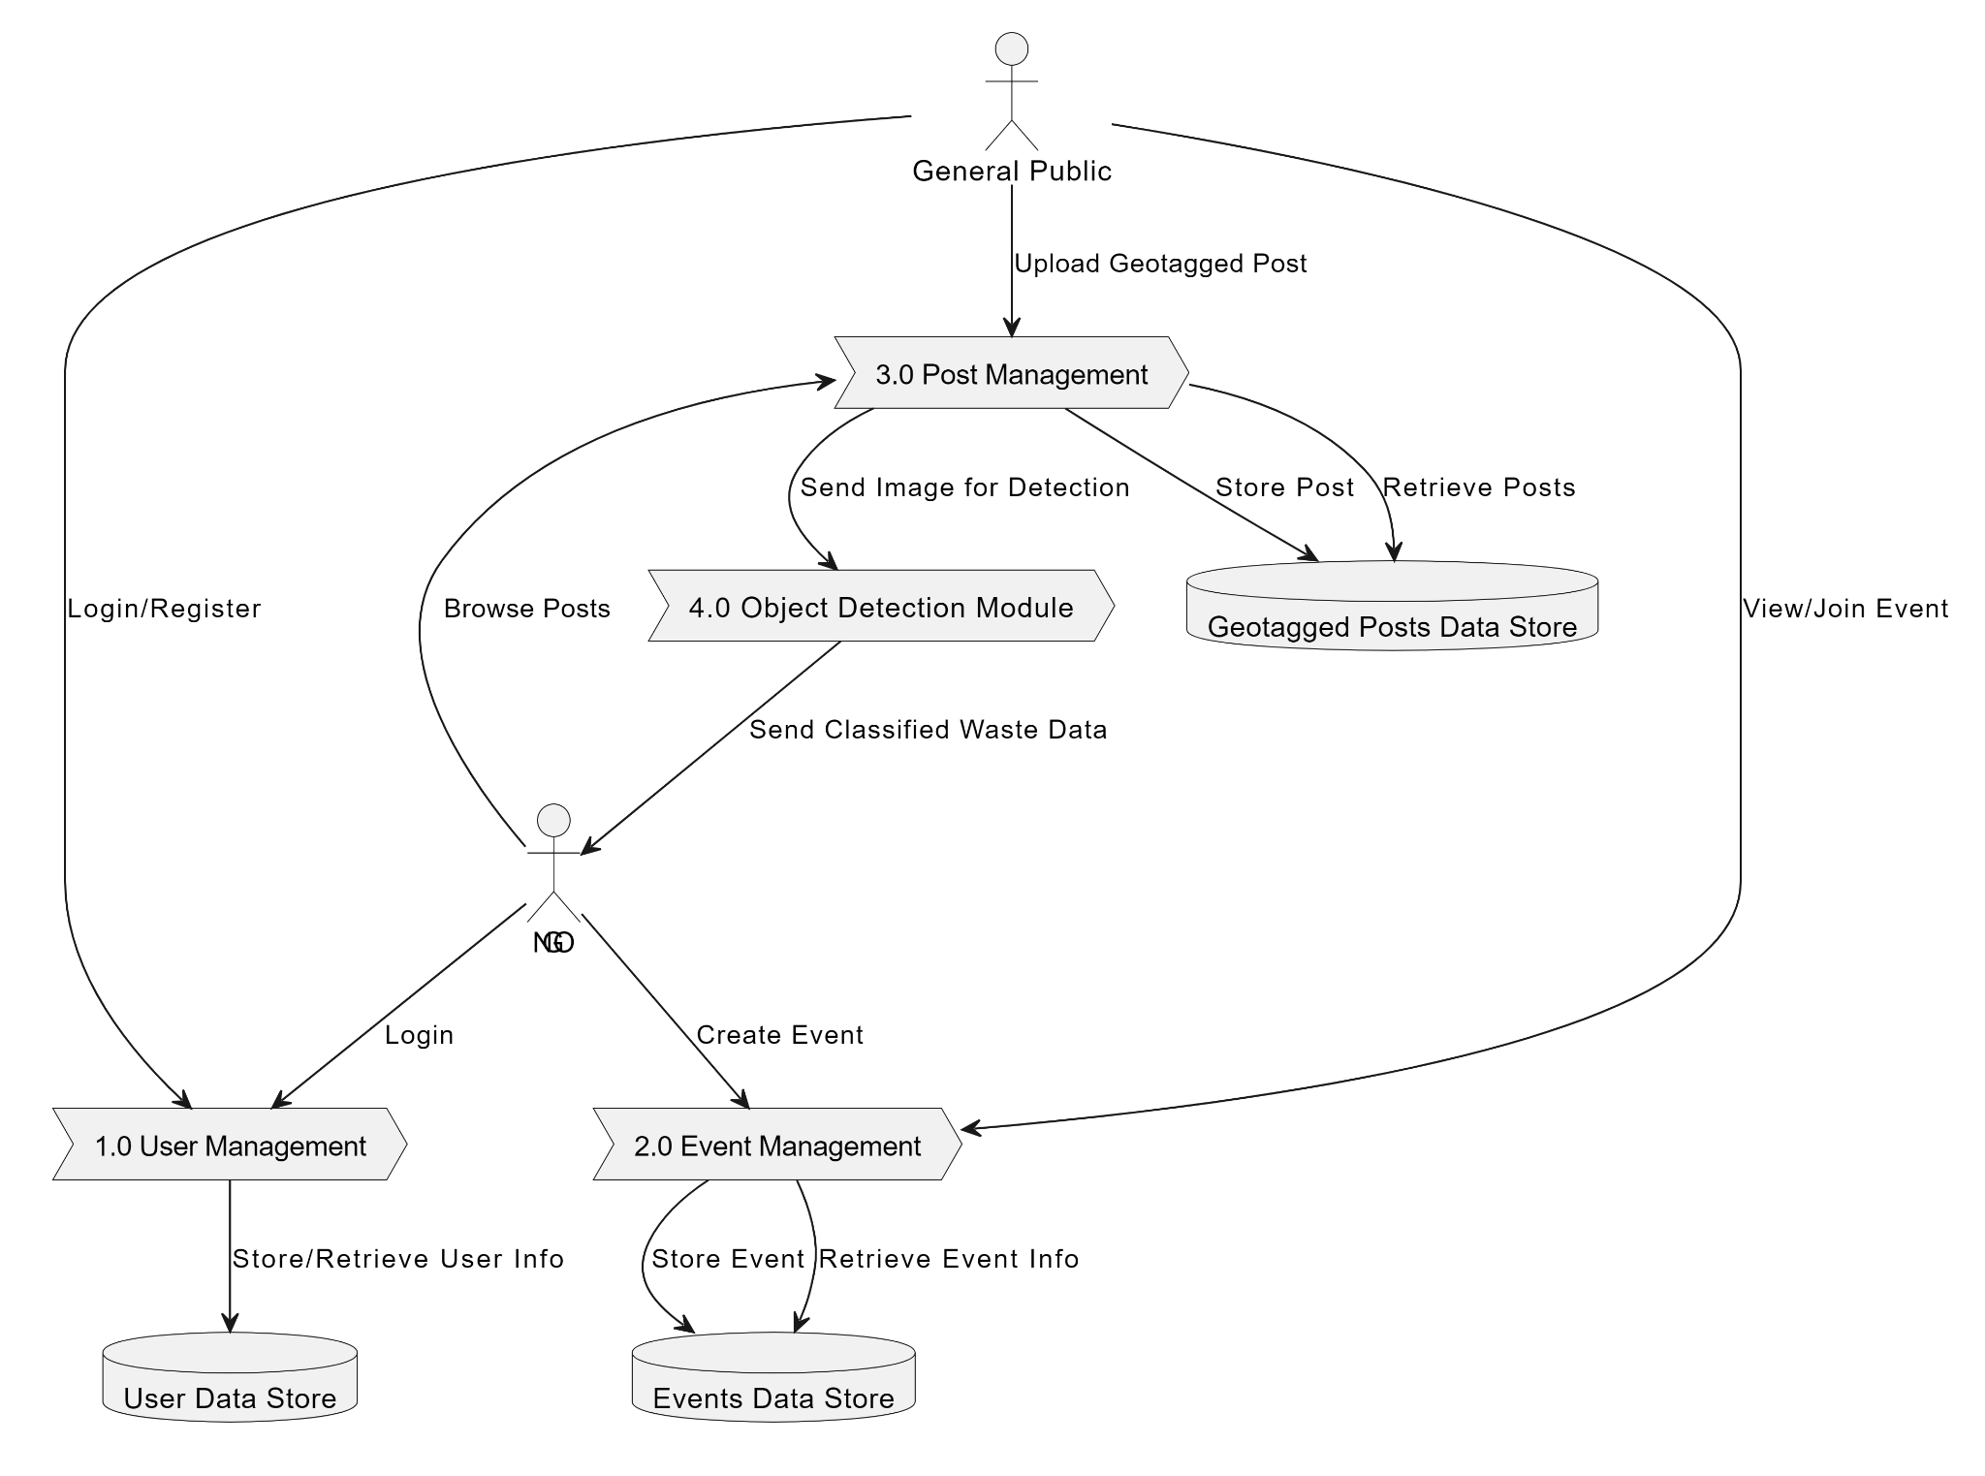

**fig 4.3.2 DFD Level 1**

This Data Flow Diagram (DFD) Level 1 demonstrates the flow of information within the EnviroScan system. It starts with the general public and NGOs interacting with various system components. Users can upload geotagged posts, which are managed by the "Post Management" process and sent to the "Object Detection Module" for classification into categories like Glass, Bin, Metal, Plastic, and Other. The posts are then stored in the Geotagged Posts Data Store. Users can also browse posts, view, and join events. The "User Management" process handles user login and registration, storing user information in the User Data Store. Lastly, the "Event Management" process allows users to create and manage events, with event details stored in the Events Data Store

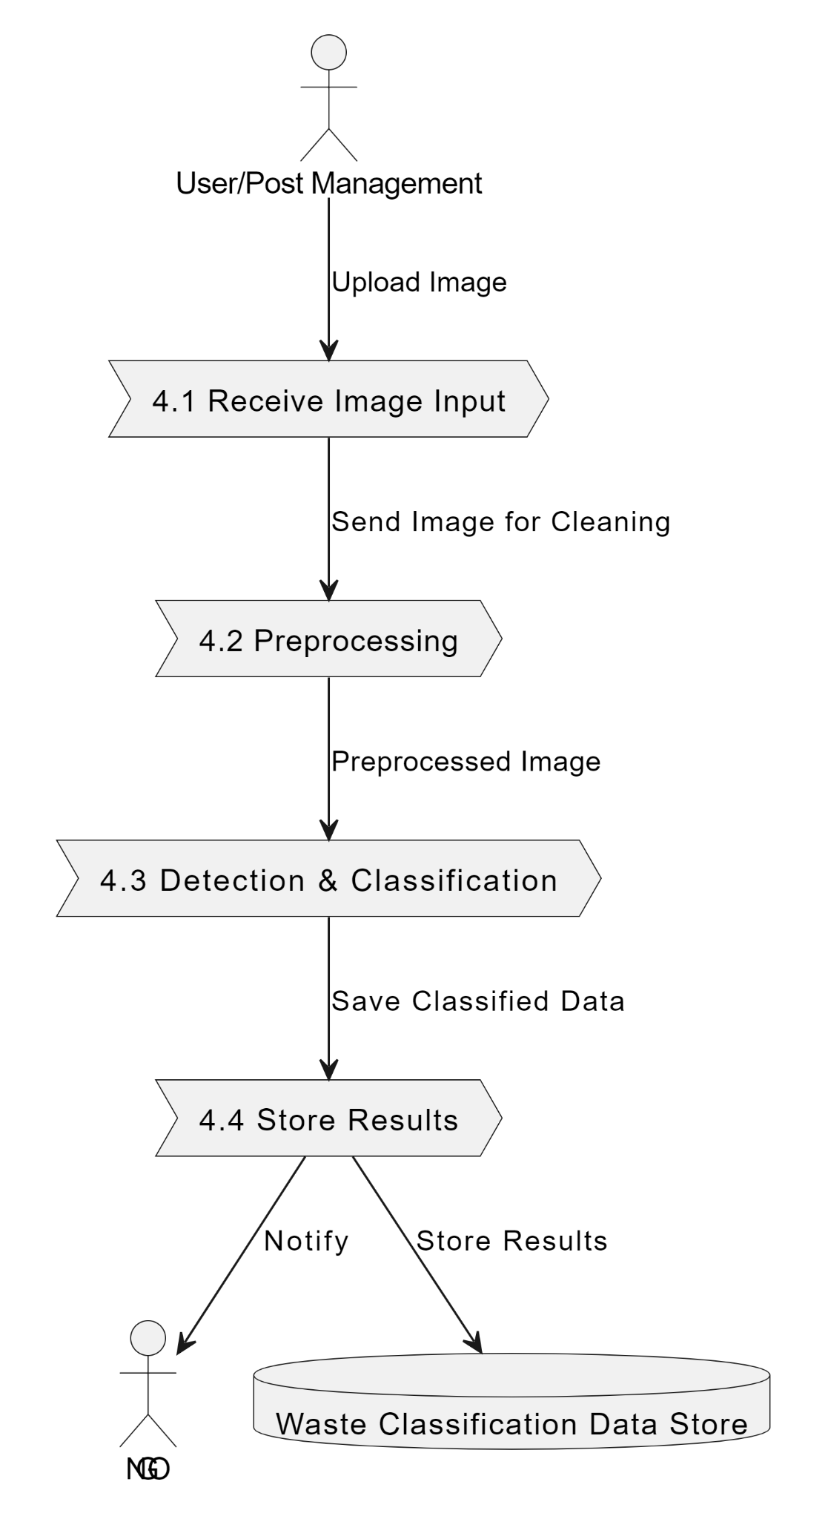

**fig 4.3.3 DFD Level 2**

This Data Flow Diagram (DFD) Level 2 delves deeper into the intricate processes of the EnviroScan system. It begins with users (both general public and NGOs) interacting with the system by uploading images of waste, logging in, registering, and participating in events. The "Receive Image Input" process accepts these images and sends them for preprocessing, ensuring the data is clean and uniform. The "Preprocessing" stage prepares the images for the "Detection & Classification" process, which then identifies and categorizes waste into specific types: Glass, Bin, Metal, Plastic, and Other. These categorized results are subsequently saved in the Waste Classification Data Store. Furthermore, the system sends notifications to NGOs regarding cleanup needs. Additionally, user management processes handle login and registration, maintaining user details in the User Data Store. Event management processes allow the creation and management of cleanup drives, with event details stored in the Events Data Store.

**b. Flowchart for the proposed system**

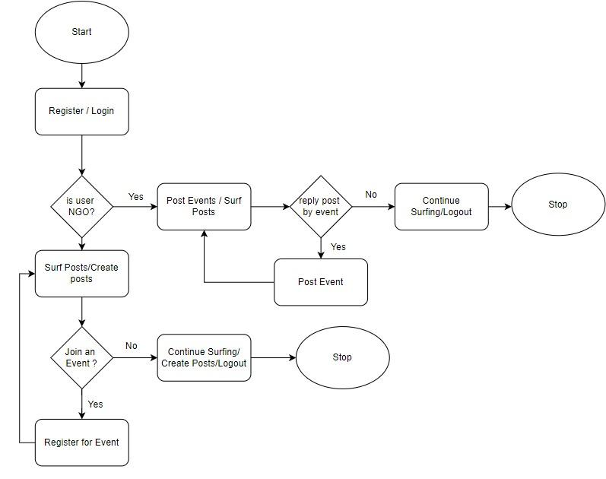

**fig 4.3.4 FlowChart**

The flowchart outlines the workflow of the EnviroScan system, starting with user registration or login. Based on whether the user is an NGO or not, they can either post or surf posts. NGOs can also reply to posts with events, while general users can create posts, explore existing ones, and choose to join events. If interested, users can register for events; otherwise, they can continue surfing, creating posts, or log out. The process ensures seamless interaction between NGOs and the public to promote participation and awareness in environmental activities.

**c. Screenshot of implementation (atleast four)**

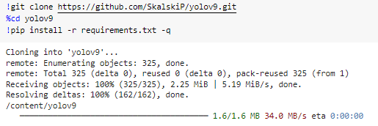

**Fig 4.4.1. Importing yolov9 model**

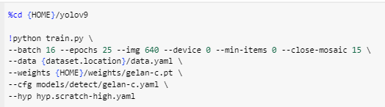

**Fig 4.4.2. Training the model**

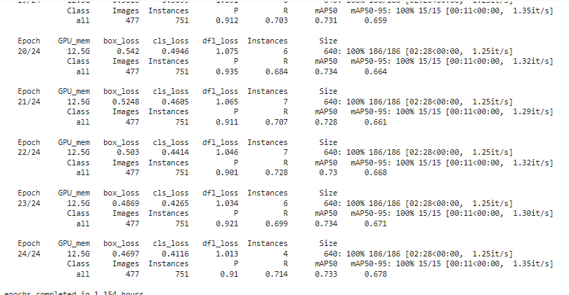

**Fig 4.4.3. Training the model in 24 epochs**

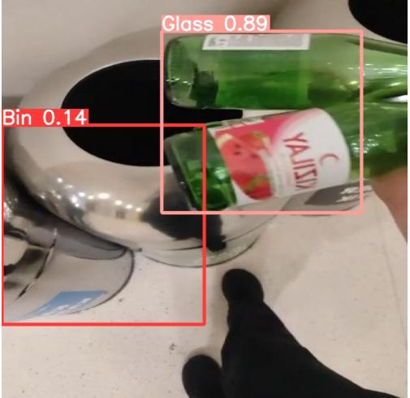

**Fig 4.4.4 Testing the model**

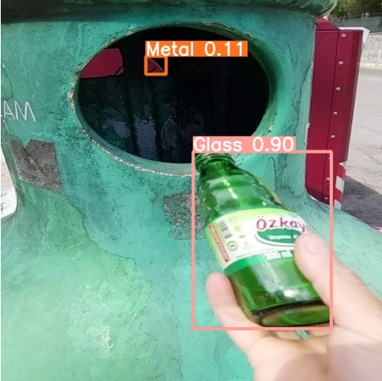

**Fig 4.4.5 Testing the model with different images**

**4.4. Project Scheduling & Tracking using Timeline / Gnatt Chart**

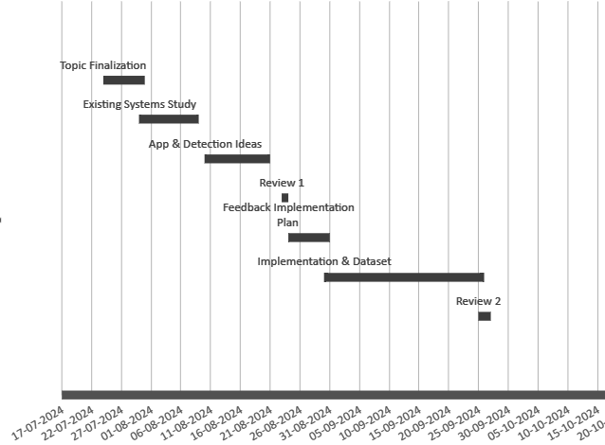

**4.4 Gantt Chart**

# 

# 5. Proposed Results and Discussions

For the EnviroScan system, here are the proposed output, equations, and evaluation parameters:

**Proposed Output:**The system is designed to deliver several critical outputs for effective waste management:

1. Real-Time Waste Detection Results:

* Display the type and quantity of waste detected using YOLO object detection. This includes the categories like glass, metal, plastic, organic, etc.
* Visualization of waste data trends over time (e.g., areas with frequent waste accumulation).

2. Data Analytics Dashboard:

* A dashboard for NGOs and administrators showing key metrics like the number of reports submitted, detection accuracy, and location-based heatmaps of waste.
* Feedback and improvement suggestions for waste management practices based on user data and trends.

3. Event and Educational Content:

* Real-time updates on waste management events organized by NGOs.
* Access to educational content and public awareness campaigns with engagement metrics.

4. User Reports and Feedback Mechanism:

* Summary of complaints, resolved issues, and community feedback.
* Notifications and alerts for users based on the reports and events they are interested in.

5. NGO Collaboration Insights:

* Statistics on participation in waste collection drives.
* Resource allocation suggestions based on detected waste density in different areas.

**Equations and Calculations**

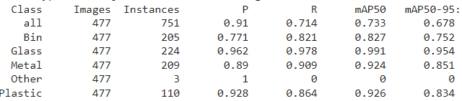

This table shows the evaluation metrics for an object detection model, likely YOLOv9, based on your earlier project context. Here's an explanation of the key elements:

1. **Class**: The different object classes being evaluated (all, Bin, Glass, Metal, Other, Plastic).
   * all aggregates the performance across all classes.
2. **Images**: The total number of images used in the evaluation (477 images).
3. **Instances**: The total number of object instances in the dataset for each class (e.g., 205 instances of "Bin").
4. **P (Precision)**: The proportion of true positive predictions out of all positive predictions made by the model.
   * Precision = TP / (TP + FP)
   * A high precision means the model has fewer false positives. For instance, the precision for Glass is 0.962, indicating high accuracy in detecting glass objects with few false positives.
5. **R (Recall)**: The proportion of true positive predictions out of all actual positives (ground truth).
   * Recall = TP / (TP + FN)
   * High recall means the model identifies most actual objects. Glass has a recall of 0.978, meaning it successfully detects most of the glass objects.
6. **mAP50 (mean Average Precision at IoU threshold 0.50)**: A common metric for object detection that averages the precision across all classes at a 50% Intersection over Union (IoU) threshold.
   * Higher values indicate better performance in detecting objects with sufficient overlap with ground truth boxes. For example, Glass has an mAP50 of 0.991, showing excellent detection performance at IoU 0.50.
7. **mAP50-95**: The mean Average Precision computed across multiple IoU thresholds (from 0.50 to 0.95).
   * This is a stricter metric, as it requires the model to be accurate across a range of IoU thresholds. Glass, again, performs well with 0.954 mAP50-95.

**Performance by Class:**

* **Glass** has the best performance overall, with high precision, recall, and mAP scores, showing the model excels at detecting glass.
* **Metal** also performs well, but slightly lower than glass.
* **Plastic** has good precision and recall, but its mAP50-95 is lower than glass and metal, suggesting the model struggles more at stricter IoU thresholds for plastic.
* **Bin** has relatively lower precision and recall, showing room for improvement.
* **Other** has very poor recall (0), meaning the model failed to detect most instances in this class.

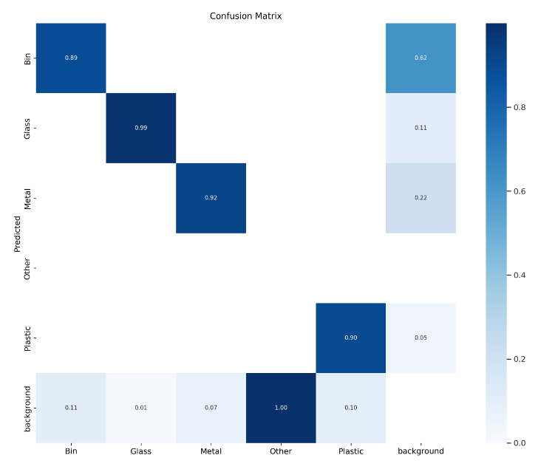

**Confusion Matrix Explanation:**

1. **Axes Description**:
   * The **X-axis** represents the actual labels of the waste categories, showing the true class labels. These categories include **Bin, Glass, Metal, Other, Plastic**, and **Background**.
   * The **Y-axis** represents the predicted labels as classified by the model, showing what the model predicted for each instance. The categories are the same as the actual labels.
2. **Diagonal Values (Correct Predictions)**:
   * The diagonal cells (from the top left to the bottom right) show the cases where the prediction was **correct** (i.e., the predicted class matches the actual class). For example:
     + **Glass** has a very high prediction accuracy with a value of **0.99**, indicating that 99% of the predictions labeled as Glass are correct.
     + **Plastic** also has a high accuracy with **0.90**.
3. **Off-Diagonal Values (Incorrect Predictions)**:
   * The off-diagonal cells represent instances where the predictions were **incorrect** (i.e., the predicted class does not match the actual class). For example:
     + There is a **0.62** value in the top right corner, indicating that some instances were incorrectly classified from another category into **Bin**.
     + Similarly, **0.11** indicates instances where predictions were wrong for the **Glass** category.
4. **Model Performance Analysis**:
   * Categories like **Glass (0.99)**, **Metal (0.92)**, and **Plastic (0.90)** show high accuracy, indicating that the model performs well in classifying these waste types.
   * The **Background** category has a significant off-diagonal value, indicating some confusion between waste and non-waste regions. This could suggest the need for additional training data or refinement of the object detection model for distinguishing background accurately.
   * The **Other** category achieved a perfect prediction rate of **1.00**, meaning that it was accurately predicted every time it appeared in the dataset.
5. **Color Scale**:
   * The color intensity in the confusion matrix ranges from light blue to dark blue.
   * **Darker blue** indicates a higher value (more accurate predictions), while **lighter blue** indicates a lower value (less accurate or more errors).

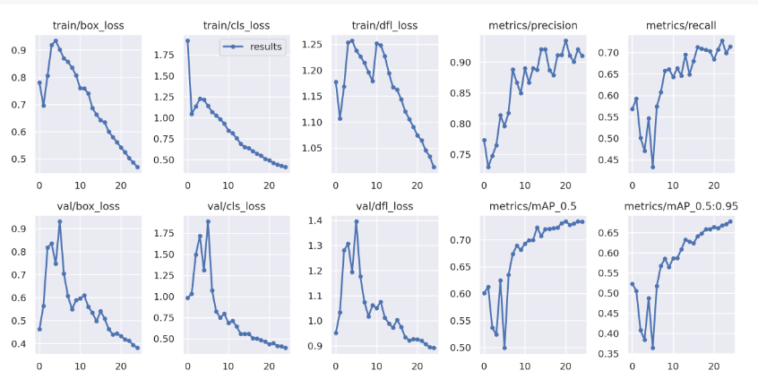

**Training Metrics:**

1. **train/box_loss**:
   * This curve represents the box regression loss during training. It is the loss associated with how well the model predicts the bounding boxes. The curve decreases over time, indicating that the model's bounding box predictions are improving as training progresses.
2. **train/cls_loss**:
   * This plot shows the classification loss during training, which measures how well the model predicts the correct class for the detected objects. The downward trend indicates better classification performance over time.
3. **train/dfl_loss**:
   * This likely refers to the "distribution focal loss" or similar type of loss, related to the confidence of the bounding boxes. The curve initially increases but then decreases, suggesting optimization after the early phase.
4. **metrics/precision**:
   * This shows the precision of the model over training epochs. Precision is the ratio of true positive detections to the total number of positive detections (true positives + false positives). It rises as the model becomes better at correctly identifying objects without too many false positives.
5. **metrics/recall**:
   * This shows the recall of the model during training, which is the ratio of true positive detections to the total number of actual positive objects. The curve rises, indicating that the model is improving at identifying more relevant objects (true positives) as training progresses.

**Validation Metrics:**

1. **val/box_loss**:
   * This is the validation box regression loss, measuring the performance of the model on unseen data. The curve decreases, showing better bounding box predictions on validation data as training progresses.
2. **val/cls_loss**:
   * This is the validation classification loss, showing how well the model predicts the correct classes for objects in the validation set. The trend decreases, indicating improvement in generalization.
3. **val/dfl_loss**:
   * Similar to the training plot, this shows the validation distribution focal loss. The curve has some fluctuations but eventually decreases, indicating that the model's confidence in bounding box predictions improves with training.
4. **metrics/mAP_0.5**:
   * This represents the mean average precision (mAP) at an Intersection over Union (IoU) threshold of 0.5. It measures how well the model performs in detecting objects with an acceptable overlap. The curve improves, showing better detection performance on the validation set.
5. **metrics/mAP_0.5:0.95**:
   * This plot represents the mAP averaged across IoU thresholds ranging from 0.5 to 0.95. A higher mAP here means that the model is performing well at different levels of overlap tolerance, showing good generalization across more strict object detection criteria.

# 6. Plan of action for the next semester

This chapter outlines the progress made in the development of our waste detection system, as well as the roadmap for the next phase of the project. It summarizes the technical advancements achieved so far and the integration plans for the YOLOv9 model with our application, which aims to create an interactive platform for environmental awareness and engagement.

**a. Work done till date :**

We have successfully worked on implementing the YOLOv9 model, which detects waste in images provided by users. The model demonstrates accurate waste identification, forming the core of our project’s waste detection functionality.

**b. Plan of action for project II :**

Our focus for the upcoming semester will be integrating the YOLO model with our app, which is designed to empower users in contributing to a better world. The app will include key features such as real-time object detection, surfing events, posts, and news articles, as well as the ability to post events and reply to posts, creating an interactive platform for environmental engagement.

# 7. Conclusions

In conclusion, the integration of deep learning techniques, particularly object detection models like YOLO and Faster RCNN, has demonstrated significant potential in improving waste management processes. Through the use of advanced image recognition technologies, waste can be accurately classified and detected in real-time, facilitating more efficient sorting and recycling. Our project, by incorporating these models, aims to contribute to environmental sustainability by providing automated solutions for waste detection and management. As we move forward, refining the model's accuracy and enhancing its integration with user-facing applications will be key to driving meaningful impact in addressing global waste challenges.

# 8. References

[1] K. Alfatmi, F. S. Shinde, M. Shahade, S. S. Sharma, S. S. Aruja and T. Y. Chaudhari, "E-Safe: An E-waste Management and Awareness Application using YOLO Object Detection," 2023 7th International Conference on Intelligent Computing and Control Systems (ICICCS), Madurai, India, 2023, pp. 1061-1066.

[2] J. Rashida, R. Hamzah, K. A. Fariza Abu Samah and S. Ibrahim, "Implementation of Faster Region-Based Convolutional Neural Network for Waste Type Classification," 2022 International Conference on Computer and Drone Applications (IConDA), Kuching, Malaysia, 2022, pp. 125-130.

[3] Karthikeyan, M., Subashini, T.S. & Jebakumar, R. SSD based waste separation in smart garbage using augmented clustering NMS. Autom Softw Eng 28, 17 (2021).

[4] A. Masand, S. Chauhan, M. Jangid, R. Kumar and S. Roy, "ScrapNet: An Efficient Approach to Trash Classification," in IEEE Access, vol. 9, pp. 130947-130958, 2021.

[5] W. Lin, "YOLO-Green: A Real-Time Classification and Object Detection Model Optimized for Waste Management," 2021 IEEE International Conference on Big Data (Big Data), Orlando, FL, USA, 2021, pp. 51-57.

[6] P. Saraswat and S. Lohia, "Smart Waste Management: Waste Segregation Using Machine Learning," on ResearchGate, 2023.

[7] Xiao, Y., Chen, B., Feng, C. et al. Recyclable solid waste detection based on image fusion and convolutional neural network. J Mater Cycles Waste Manag 26, 2043–2057 (2024).

[8] H. Li, C. Hu, X. Zhong, C. Zeng and H. Shen, "Solid Waste Detection in Cities Using Remote Sensing Imagery Based on a Location-Guided Key Point Network With Multiple Enhancements," in IEEE Journal of Selected Topics in Applied Earth Observations and Remote Sensing, vol. 16, pp. 191-201, 2023.

[9] H. Abdu and M. H. Mohd Noor, "A Survey on Waste Detection and Classification Using Deep Learning," in IEEE Access, vol. 10, pp. 128151-128165, 2022.

[10] H. Li, C. Hu, X. Zhong, C. Zeng and H. Shen, "Solid Waste Detection in Cities Using Remote Sensing Imagery Based on a Location-Guided Key Point Network With Multiple Enhancements," in IEEE Journal of Selected Topics in Applied Earth Observations and Remote Sensing, vol. 16, pp. 191-201, 2023.

# 9. Appendix

**a. List of Figures**

| Figure Number | Heading | Page no. |
| --- | --- | --- |
| 4.1 | Block Diagram | 26 |
| 4.2 | Modular Diagram | 29 |
| 4.3.1 | DFD Level 0 | 30 |
| 4.3.2 | DFD Level 1 | 31 |
| 4.3.3 | DFD Level 2 | 32 |
| 4.3.4 | Flow Chart | 33 |
| 4.4.1 | Importing YOLOv9 model | 34 |
| 4.4.2 | Training the model | 34 |
| 4.4.3 | Training the model in 25 epochs | 34 |
| 4.4.4 | Testing the model | 35 |
| 4.4.5 | Testing the model with different images | 35 |
| 4.4 | Gantt Chart | 36 |

**b. Paper Publications :-**

We are currently in the process of drafting our paper. Upon completion, we will proceed with publication and generate the necessary documents, including the plagiarism report and the publication certificate. We are committed to ensuring a high standard of quality before submission and look forward to sharing our findings soon.

1. **Xerox of project review sheet (1 per student )**

